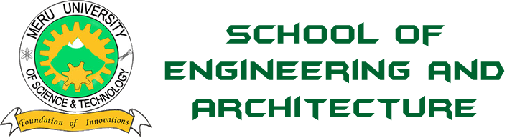
MERU UNIVERSITY OF SCIENCE AND TECHNOLOGY
DEPARTMENT OF ELECTRICAL AND ELECTRONICS ENGINEERING

BACHELOR OF TECHNOLOGY IN ELECTRICTRAL AND ELECTRONIS ENGINEERING

TITLE: LAB REPORT: The Physical Components of a Computer Disassembling and Assembling.

NAME: JOSHUA MUTHENYA WAMBUA
REG NO: EG209/109705/22
UNIT CODE: 3401
DESCRIPTION: COMPUTER HARDWARE AND MAINTENANCE.
DATE:05/12/2025

Introduction

A computer is an electronic device that accepts data from input devices, processes the data into meaningful information and outputs the information through output devices. A computer is made up of various physical components collectively known as hardware. Understanding these components and how they interconnect is essential for effective computer assembly, maintenance, troubleshooting, and repair. This practical aimed at giving me hands-on experience with identifying internal components, safely disassembling a computer, reassembling it, and performing basic tests to ensure proper operation. The ability to handle hardware correctly reduces the risk of damage and enhances competence in maintenance procedures.

Objectives
- To identify the physical components of a personal computer.
- To understand and apply safety precautions when working with hardware.
- To disassemble a personal computer correctly.
- To assemble a personal computer from its components.
- To test and troubleshoot the computer after assembly.
- To build confidence in handling computer hardware systems.

Materials and tools used
Tools
- Screwdrivers (Philips and flat-head)
- Anti-static wrist strap
- Thermal paste
- Multimeter

- Cable ties
Materials & Hardware Components
- System Unit
- Motherboard
- Central Processing Unit (CPU)
- Random Access Memory (RAM)
- Power Supply Unit (PSU)
- Storage devices (HDD)
- Cooling fan & heat sink
- Expansion cards (GPU, NIC)
- Cables (SATA, power connectors, front-panel connectors)

Procedures
Steps for Disassembling a Personal Computer
- Power off the computer and unplug all cables.
- Press the power button for a few seconds to discharge remaining power.
- Remove the side panel of the PC case.
- Document or take pictures of component layout and cable connections.
- Disconnect power cables from the motherboard and drives.
- Remove storage devices, GPU, and expansion cards.
- Remove RAM modules.
- Detach the CPU fan and heat sink.
- Unlock and remove the CPU from the socket.
- Remove the motherboard from the case.
- Inspect all components for damage, dust, or loose connections.
Steps for Assembling a Personal Computer
- Install the motherboard back into the case and screw it securely.
- Insert the CPU into its socket and apply thermal paste.
- Mount the heat sink and CPU fan.
- Install RAM modules into their slots.
- Reinstall storage devices (HDD/SSD).
- Install expansion cards (GPU, NIC, etc.).
- Connect power cables (24-pin, 8-pin CPU, SATA power).
- Connect data cables such as SATA cables.
- Reconnect front panel connectors (power switch, USB, LEDs).
- Organize cables using ties to improve airflow.
- Close the side panel and reconnect external cables.
5.5 Testing and Troubleshooting
After assembly, the following tests were performed:
Power Test
- The system powered on without abnormal noises or smoke.
POST (Power-On Self Test)
- The BIOS screen displayed successfully, confirming proper CPU, RAM, and system integrity.
Troubleshooting Steps (if required)
- Checked loose cables or RAM not properly seated.
- Ensured the CPU fan was connected to CPU fan header.
- Verified PSU switches and connectors.
- Tested components individually if no display appeared.

6. Conclusion
The practical session successfully enhanced understanding of computer hardware components and safe handling procedures. Students gained hands-on experience in disassembling and assembling a computer, identifying hardware, and performing troubleshooting steps.
This knowledge is essential for effective computer maintenance and forms a foundation for advanced hardware engineering and diagnostics.

7. References
- Computer Hardware and Maintenance – Lecture Notes
- Cisco IT Essentials Hardware Guide
- Intel® Processor and Motherboard Installation Guidelines
- Murdoch University Hardware Maintenance Tutorials
- Practical demonstrations by the instructor (Eng. P.N.K)

Results
During the practical session, the personal computer was successfully disassembled, inspected, and reassembled. All major components were identified, cleaned, and evaluated for integrity. After reassembly, the computer powered on successfully and booted without errors.
All tests for functionality including display output, fan operation, power delivery, and BIOS signal checks passed as expected.

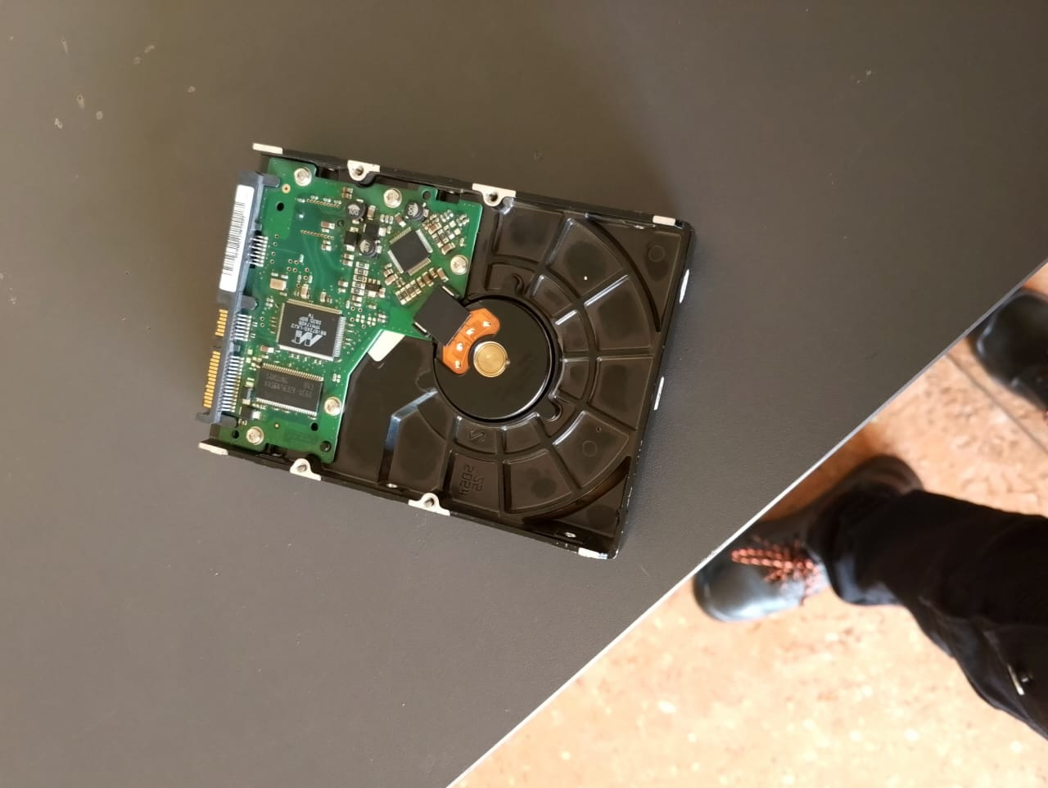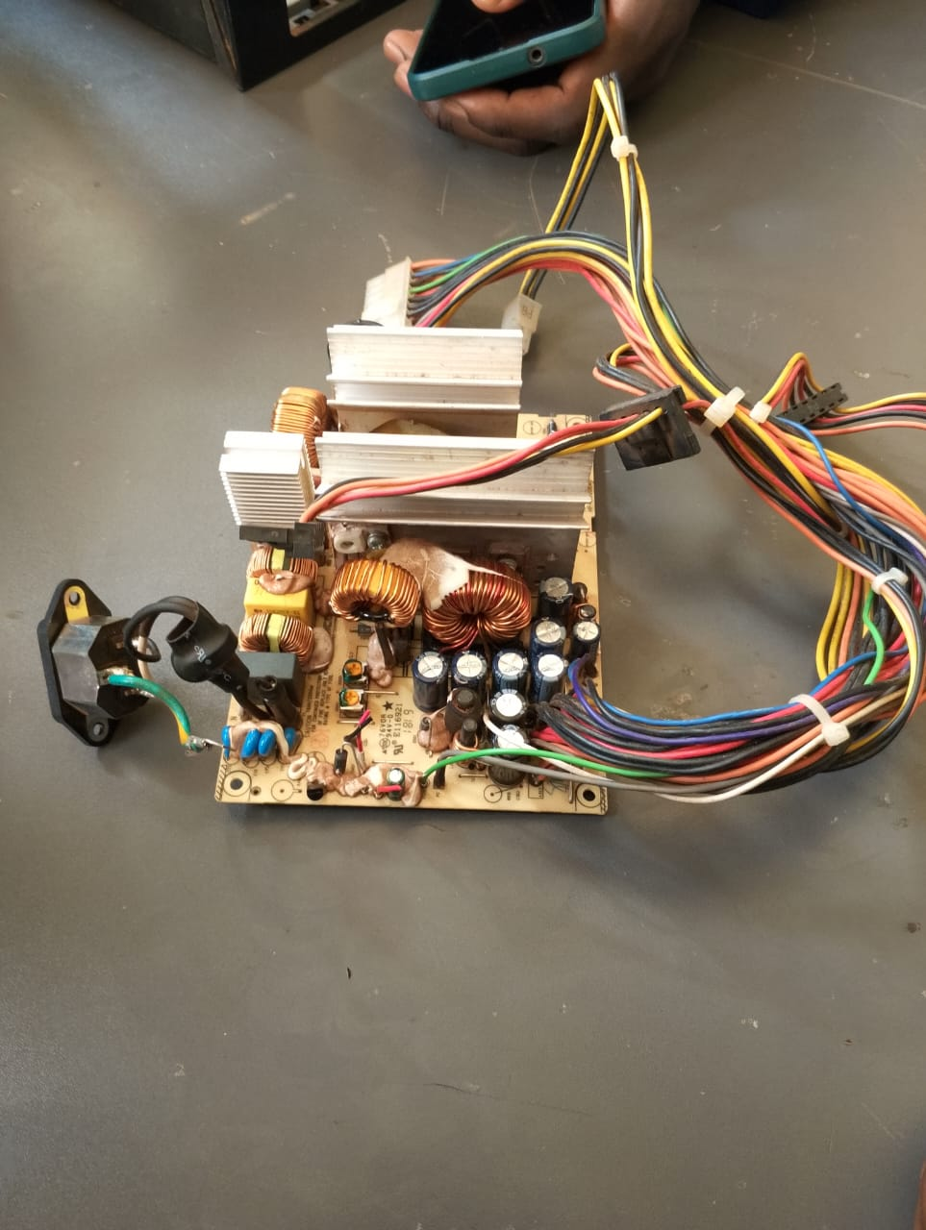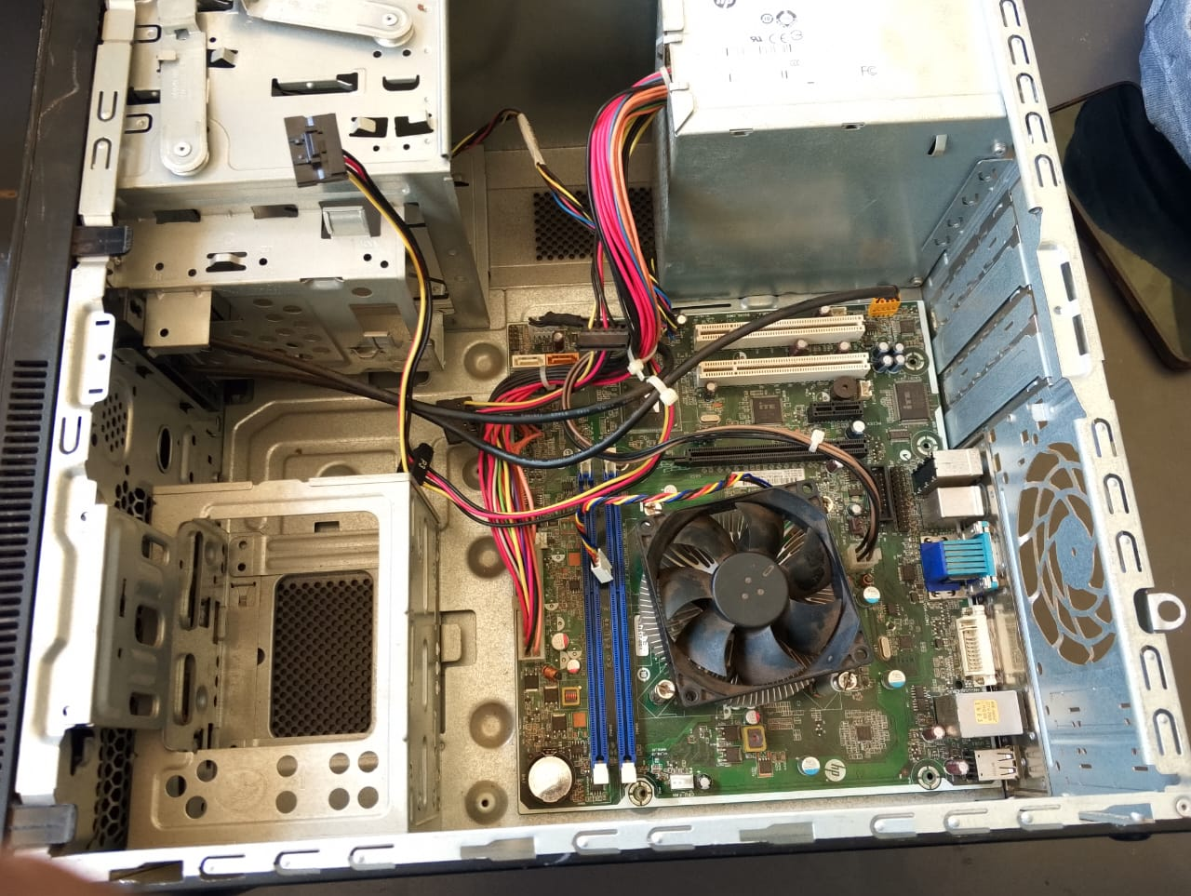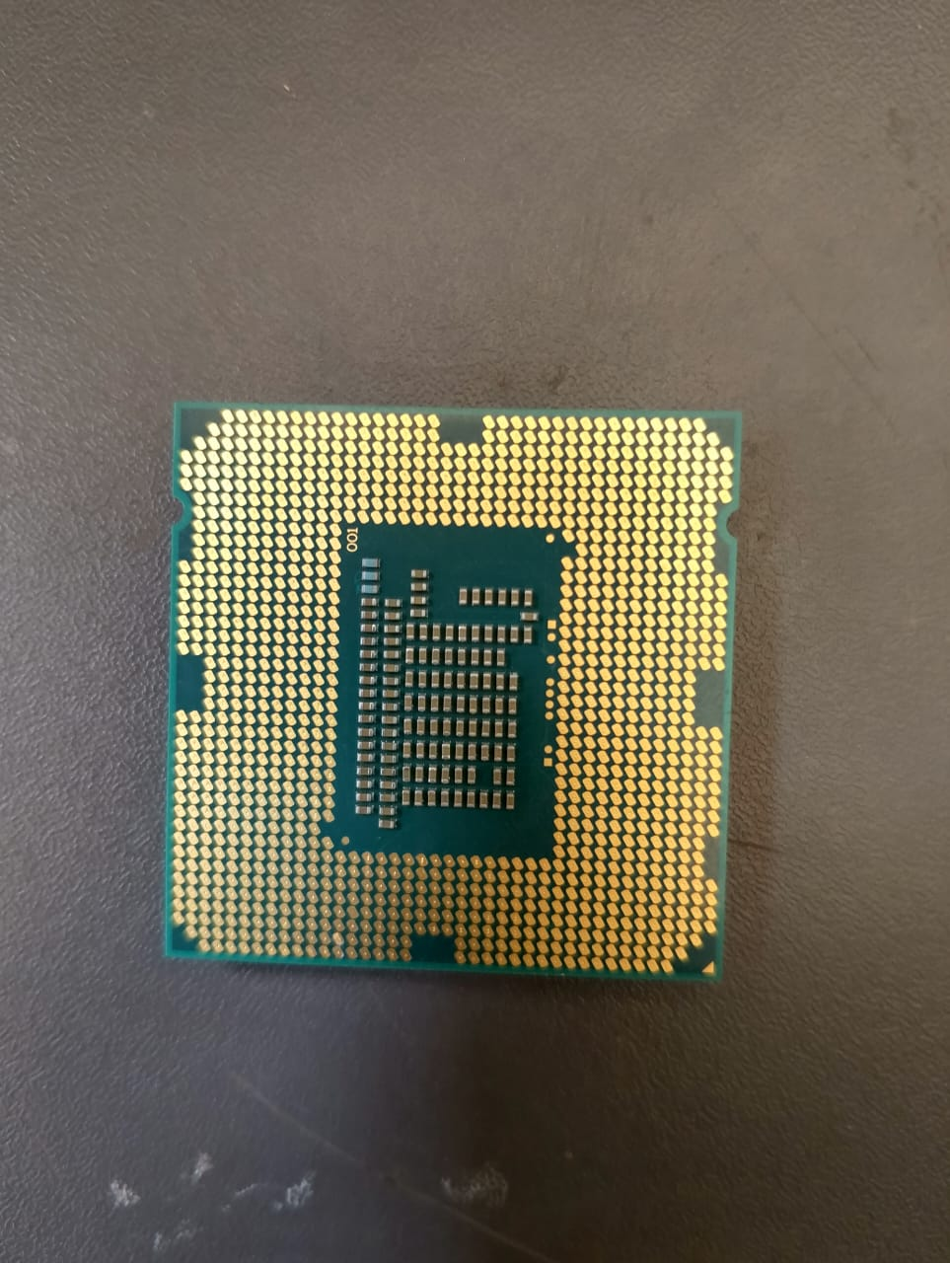
Discussions

Conclusion

References

